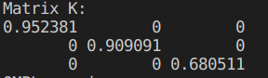

Matrix K:

0.952381 0 0

0 0.909091 0

0 0 0.680511